**IMPORTANT NOTICE –**

**PRODUCT PACKAGING UPDATE** **AND**

**PRODUCT DISCONTINUED**

**BARASTOC 3 GRAIN SCRATCH MIX**

**BARASTOC DARLING DOWNS**

At Ridley, providing quality, nutritious feed for your backyard chooks is something we’re passionate about. The Barastoc range is focused on providing complete and balanced feeds for all backyard chickens, so we’re making some changes.

**WHAT’S CHANGING?**

**Barastoc 3 Grain Scratch Mix 20kg (110337)** will be discontinued from early April 2025. Orders received before this time will be fulfilled as per current arrangements.

**Barastoc Darling Downs 20kg (100711)** is being re-named to **Barastoc Grain Mix (402028)**. It is the same feed, with great new packaging and a new name.

We are encouraging **Barastoc 3 Grain Scratch Mix 20kg (110337)** customers to upgrade to **Barastoc Grain Mix (402028)**. This is a complete feed, designed to encourage egg production.

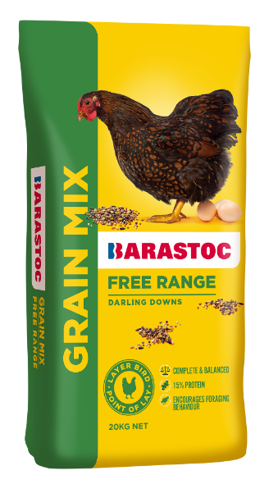From April, customers ordering **Barastoc Darling Downs 20kg (100711)** will start to receive the new **Barastoc Grain Mix (402028)** at the same price, which is the same great feed, but with new packaging and a new name.

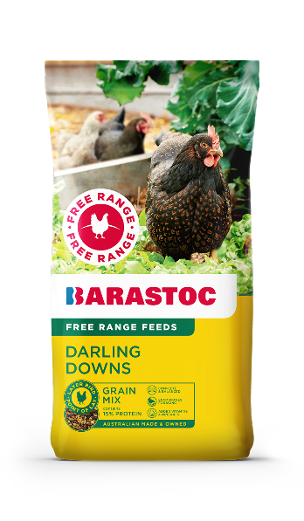

In the event that any of your customers have questions that you are unable to answer from this notice, please contact either your local Territory Manager or our customer service team.

Ridley Sales & Support team on 1300 666 657 or email: [ridleyinquiries@ridley.com.au](mailto:ridleyinquiries@ridley.com.au)

|  |  |  |
| --- | --- | --- |
| **PRODCT CODE** | **PRODUCT NAME** | **Bag Image** |
| **110337** – Being discontinued  April 2025 | **Barastoc 3 Grain Scratch Mix 20kg**  A blend of grains and seeds designed for supplementary feeding. For all bird breeds from 16 weeks of age.  **NUTRIENT LEVELS**  Min Crude Protein 10.0%  Min Calcium 2.0% |  |
| **100711** – Old bag artwork  Packaging phased out by end of April 2025 | **Barastoc Darling Downs 20kg**  A nutritious, balanced and complete vegetarian feed formulated from natural ingredients for laying hens in a home flock. Suitable for most breeds of laying poultry. ****NUTRIENT LEVELS**** Min Crude Protein 15%  Min Calcium 3.8%  Typical analysis as fed / kg. |  |
| **402028** – New packaging, new name, same feed, replacing Darling Downs. Available from April/May 2025. | **Barastoc Grain Mix 20kg**  A nutritious, balanced and complete vegetarian feed formulated from natural ingredients for laying hens in a home flock. Suitable for most breeds of laying poultry. ****NUTRIENT LEVELS**** Min Crude Protein 15%  Min Calcium 3.8%  Typical analysis as fed / kg. |  |